**Hands on 1**

**Create a Spring Web Project using Maven**

**HelloController**  
package com.cognizant.springlearn.controller;

import org.springframework.web.bind.annotation.GetMapping;

import org.springframework.web.bind.annotation.RestController;

@RestController

public class HelloController {

@GetMapping("/")

public String sayHello() {

return "Welcome to Spring Learn!";

}

}

**SpringLearnApplication**

package com.cognizant.springlearn;

import org.springframework.boot.SpringApplication;

import org.springframework.boot.autoconfigure.SpringBootApplication;

@SpringBootApplication

public class SpringLearnApplication {

public static void main(String[] args) {

SpringApplication.run(SpringLearnApplication.class, args);

System.out.println("SpringLearnApplication has started successfully!");

}

}

**pom.xml**

<project xmlns="http://maven.apache.org/POM/4.0.0" xmlns:xsi="http://www.w3.org/2001/XMLSchema-instance" xsi:schemaLocation="http://maven.apache.org/POM/4.0.0 http://maven.apache.org/xsd/maven-4.0.0.xsd">

<modelVersion>4.0.0</modelVersion>

<groupId>com.cognizant</groupId>

<artifactId>spring-learn</artifactId>

<version>0.0.1-SNAPSHOT</version>

<name>spring-learn</name>

<description>Spring Boot Web Project</description>

<packaging>jar</packaging>

<parent>

<groupId>org.springframework.boot</groupId>

<artifactId>spring-boot-starter-parent</artifactId>

<version>3.1.4</version>

<relativePath/>

</parent>

<properties>

<java.version>17</java.version>

</properties>

<dependencies>

<dependency>

<groupId>org.springframework.boot</groupId>

<artifactId>spring-boot-starter-web</artifactId>

</dependency>

<dependency>

<groupId>org.springframework.boot</groupId>

<artifactId>spring-boot-devtools</artifactId>

<scope>runtime</scope>

<optional>true</optional>

</dependency>

<dependency>

<groupId>org.springframework.boot</groupId>

<artifactId>spring-boot-starter-test</artifactId>

<scope>test</scope>

</dependency>

</dependencies>

<build>

<plugins>

<plugin>

<groupId>org.springframework.boot</groupId>

<artifactId>spring-boot-maven-plugin</artifactId>

<version>3.1.4</version>

</plugin>

</plugins>

</build>

</project>

**application.properties**

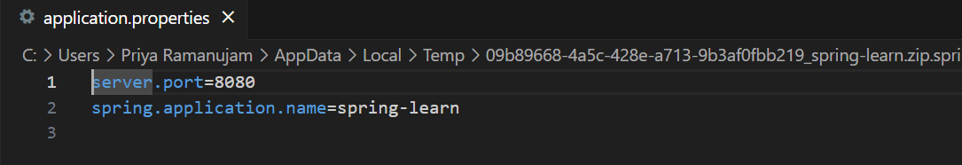

**Hello World RESTful Web Service**   
  
**HelloController**

package com.cognizant.springlearn.controller;

import org.slf4j.Logger;

import org.slf4j.LoggerFactory;

import org.springframework.web.bind.annotation.*;

@RestController

public class HelloController {

private static final Logger LOGGER = LoggerFactory.getLogger(HelloController.class);

@GetMapping("/hello")

public String sayHello() {

LOGGER.info("START - sayHello()");

String response = "Hello World!!";

LOGGER.info("END - sayHello()");

return response;

}

}

**SpringLearnApplication**

package com.cognizant.springlearn;

import org.springframework.boot.SpringApplication;

import org.springframework.boot.autoconfigure.SpringBootApplication;

@SpringBootApplication

public class SpringLearnApplication {

public static void main(String[] args) {

SpringApplication.run(SpringLearnApplication.class, args);

}

}

**pom.xml**

<project xmlns="http://maven.apache.org/POM/4.0.0" xmlns:xsi="http://www.w3.org/2001/XMLSchema-instance" xsi:schemaLocation="http://maven.apache.org/POM/4.0.0 http://maven.apache.org/xsd/maven-4.0.0.xsd">

<modelVersion>4.0.0</modelVersion>

<groupId>com.cognizant</groupId>

<artifactId>spring-learn</artifactId>

<version>0.0.1-SNAPSHOT</version>

<packaging>jar</packaging>

<name>spring-learn</name>

<description>Spring Boot Hello World</description>

<parent>

<groupId>org.springframework.boot</groupId>

<artifactId>spring-boot-starter-parent</artifactId>

<version>3.2.0</version>

</parent>

<dependencies>

<dependency>

<groupId>org.springframework.boot</groupId>

<artifactId>spring-boot-starter-web</artifactId>

</dependency>

<dependency>

<groupId>org.springframework.boot</groupId>

<artifactId>spring-boot-starter-logging</artifactId>

</dependency>

</dependencies>

<build>

<plugins>

<plugin>

<groupId>org.springframework.boot</groupId>

<artifactId>spring-boot-maven-plugin</artifactId>

</plugin>

</plugins>

</build>

</project>

**application.properties**

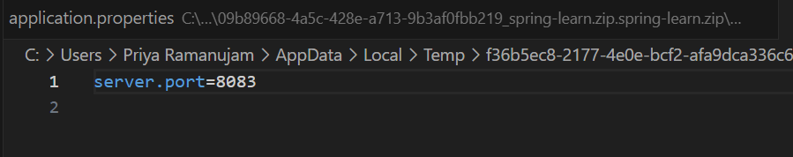

**REST - Country Web Service** 

**pom.xml**

<project xmlns="http://maven.apache.org/POM/4.0.0" xmlns:xsi="http://www.w3.org/2001/XMLSchema-instance" xsi:schemaLocation="http://maven.apache.org/POM/4.0.0 http://maven.apache.org/xsd/maven-4.0.0.xsd">

<modelVersion>4.0.0</modelVersion>

<groupId>com.cognizant</groupId>

<artifactId>spring-learn</artifactId>

<version>0.0.1-SNAPSHOT</version>

<packaging>jar</packaging>

<name>spring-learn</name>

<description>Spring Boot Hello World</description>

<parent>

<groupId>org.springframework.boot</groupId>

<artifactId>spring-boot-starter-parent</artifactId>

<version>3.2.0</version>

</parent>

<dependencies>

<dependency>

<groupId>org.springframework.boot</groupId>

<artifactId>spring-boot-starter-web</artifactId>

</dependency>

<dependency>

<groupId>org.springframework.boot</groupId>

<artifactId>spring-boot-starter-logging</artifactId>

</dependency>

</dependencies>

<build>

<plugins>

<plugin>

<groupId>org.springframework.boot</groupId>

<artifactId>spring-boot-maven-plugin</artifactId>

</plugin>

</plugins>

</build>

</project>

**CountryController**

package com.cognizant.springlearn.controller;

import com.cognizant.springlearn.model.Country;

import org.slf4j.Logger;

import org.slf4j.LoggerFactory;

import org.springframework.beans.factory.BeanFactory;

import org.springframework.context.support.ClassPathXmlApplicationContext;

import org.springframework.web.bind.annotation.RequestMapping;

import org.springframework.web.bind.annotation.RestController;

@RestController

public class CountryController {

private static final Logger LOGGER = LoggerFactory.getLogger(CountryController.class);

@RequestMapping("/country")

public Country getCountryIndia() {

LOGGER.info("START - getCountryIndia()");

BeanFactory context = new ClassPathXmlApplicationContext("country.xml");

Country country = (Country) context.getBean("in");

LOGGER.info("END - getCountryIndia()");

return country;

}

}

**Country**

package com.cognizant.springlearn.model;

public class Country {

private String code;

private String name;

public Country() {}

public Country(String code, String name) {

this.code = code;

this.name = name;

}

public String getCode() {

return code;

}

public void setCode(String code) {

this.code = code;

}

public String getName() {

return name;

}

public void setName(String name) {

this.name = name;

}

}

**SpringLearnApplication**

package com.cognizant.springlearn;

import org.springframework.boot.SpringApplication;

import org.springframework.boot.autoconfigure.SpringBootApplication;

@SpringBootApplication

public class SpringLearnApplication {

public static void main(String[] args) {

SpringApplication.run(SpringLearnApplication.class, args);

}

}

**application.properties**



**Country**

<beans xmlns="http://www.springframework.org/schema/beans" xmlns:xsi="http://www.w3.org/2001/XMLSchema-instance" xsi:schemaLocation="http://www.springframework.org/schema/beans http://www.springframework.org/schema/beans/spring-beans.xsd">

<bean id="in" class="com.cognizant.springlearn.model.Country">

<property name="code" value="IN"/>

<property name="name" value="India"/>

</bean>

</beans>

**REST - Get country based on country code** 

**CountryController**

package com.cognizant.springlearn.controller;

import com.cognizant.springlearn.model.Country;

import com.cognizant.springlearn.service.CountryService;

import org.slf4j.Logger;

import org.slf4j.LoggerFactory;

import org.springframework.beans.factory.annotation.Autowired;

import org.springframework.web.bind.annotation.*;

@RestController

public class CountryController {

private static final Logger LOGGER = LoggerFactory.getLogger(CountryController.class);

@Autowired

private CountryService countryService;

@GetMapping("/countries/{code}")

public Country getCountry(@PathVariable String code) {

LOGGER.info("START - getCountry()");

Country country = countryService.getCountry(code);

LOGGER.info("END - getCountry()");

return country;

}

}

**Country**

package com.cognizant.springlearn.model;

public class Country {

private String code;

private String name;

public Country() {}

public Country(String code, String name) {

this.code = code;

this.name = name;

}

public String getCode() {

return code;

}

public void setCode(String code) {

this.code = code;

}

public String getName() {

return name;

}

public void setName(String name) {

this.name = name;

}

}

**CountryService**

package com.cognizant.springlearn.service;

import com.cognizant.springlearn.model.Country;

import org.springframework.beans.factory.BeanFactory;

import org.springframework.context.support.ClassPathXmlApplicationContext;

import org.springframework.stereotype.Service;

import java.util.List;

@Service

public class CountryService {

public Country getCountry(String code) {

BeanFactory context = new ClassPathXmlApplicationContext("country.xml");

List<Country> countryList = (List<Country>) context.getBean("countryList");

return countryList.stream()

.filter(c -> c.getCode().equalsIgnoreCase(code))

.findFirst()

.orElse(null);

}

}

**SpringLearnApplication**

package com.cognizant.springlearn;

import org.springframework.boot.SpringApplication;

import org.springframework.boot.autoconfigure.SpringBootApplication;

@SpringBootApplication

public class SpringLearnApplication {

public static void main(String[] args) {

SpringApplication.run(SpringLearnApplication.class, args);

}

}

**application.properties**



<beans xmlns="http://www.springframework.org/schema/beans" xmlns:xsi="http://www.w3.org/2001/XMLSchema-instance" xsi:schemaLocation="http://www.springframework.org/schema/beans http://www.springframework.org/schema/beans/spring-beans.xsd">

<bean id="countryList" class="java.util.ArrayList">

<constructor-arg>

<list>

<bean class="com.cognizant.springlearn.model.Country">

<property name="code" value="IN"/>

<property name="name" value="India"/>

</bean>

<bean class="com.cognizant.springlearn.model.Country">

<property name="code" value="US"/>

<property name="name" value="United States"/>

</bean>

<bean class="com.cognizant.springlearn.model.Country">

<property name="code" value="CN"/>

<property name="name" value="China"/>

</bean>

</list>

</constructor-arg>

</bean>

</beans>

**pom.xml**

<project xmlns="http://maven.apache.org/POM/4.0.0" xmlns:xsi="http://www.w3.org/2001/XMLSchema-instance" xsi:schemaLocation="http://maven.apache.org/POM/4.0.0 http://maven.apache.org/xsd/maven-4.0.0.xsd">

<modelVersion>4.0.0</modelVersion>

<groupId>com.cognizant</groupId>

<artifactId>spring-learn</artifactId>

<version>0.0.1-SNAPSHOT</version>

<packaging>jar</packaging>

<name>spring-learn</name>

<description>Spring Boot Hello World</description>

<parent>

<groupId>org.springframework.boot</groupId>

<artifactId>spring-boot-starter-parent</artifactId>

<version>3.2.0</version>

</parent>

<dependencies>

<dependency>

<groupId>org.springframework.boot</groupId>

<artifactId>spring-boot-starter-web</artifactId>

</dependency>

<dependency>

<groupId>org.springframework.boot</groupId>

<artifactId>spring-boot-starter-logging</artifactId>

</dependency>

</dependencies>

<build>

<plugins>

<plugin>

<groupId>org.springframework.boot</groupId>

<artifactId>spring-boot-maven-plugin</artifactId>

</plugin>

</plugins>

</build>

</project>

**Hands on 4**

**Spring Core – Load Country from Spring Configuration XML** 

**HelloController**

package com.cognizant.springlearn.controller;

import org.springframework.web.bind.annotation.GetMapping;

import org.springframework.web.bind.annotation.RestController;

@RestController

public class HelloController {

@GetMapping("/")

public String sayHello() {

return "Welcome to Spring Learn!";

}

}

**SpringLearnApplication**

package com.cognizant.springlearn;

import org.springframework.boot.SpringApplication;

import org.springframework.boot.autoconfigure.SpringBootApplication;

@SpringBootApplication

public class SpringLearnApplication {

public static void main(String[] args) {

SpringApplication.run(SpringLearnApplication.class, args);

System.out.println("SpringLearnApplication has started successfully!");

}

}

**application.properties**

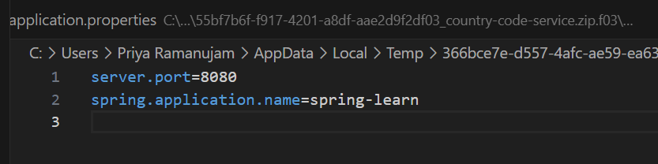

**pom.xml**

<project xmlns="http://maven.apache.org/POM/4.0.0" xmlns:xsi="http://www.w3.org/2001/XMLSchema-instance" xsi:schemaLocation="http://maven.apache.org/POM/4.0.0 http://maven.apache.org/xsd/maven-4.0.0.xsd">

<modelVersion>4.0.0</modelVersion>

<groupId>com.cognizant</groupId>

<artifactId>spring-learn</artifactId>

<version>0.0.1-SNAPSHOT</version>

<name>spring-learn</name>

<description>Spring Boot Web Project</description>

<packaging>jar</packaging>

<parent>

<groupId>org.springframework.boot</groupId>

<artifactId>spring-boot-starter-parent</artifactId>

<version>3.1.4</version>

<relativePath/>

</parent>

<properties>

<java.version>17</java.version>

</properties>

<dependencies>

<dependency>

<groupId>org.springframework.boot</groupId>

<artifactId>spring-boot-starter-web</artifactId>

</dependency>

<dependency>

<groupId>org.springframework.boot</groupId>

<artifactId>spring-boot-devtools</artifactId>

<scope>runtime</scope>

<optional>true</optional>

</dependency>

<dependency>

<groupId>org.springframework.boot</groupId>

<artifactId>spring-boot-starter-test</artifactId>

<scope>test</scope>

</dependency>

</dependencies>

<build>

<plugins>

<plugin>

<groupId>org.springframework.boot</groupId>

<artifactId>spring-boot-maven-plugin</artifactId>

<version>3.1.4</version>

</plugin>

</plugins>

</build>

</project>